Internship Report on “Client Coordination and Internal Communication in the Marketing Department of Younus Group”

Azim Ahmed Rohan

This report is submitted to the school of Business and Economics, United International University as a partial requirement for the degree fulfillment of Bachelor of Business Administration

Internship Report on “Client Coordination and Internal Communication in the Marketing Department of Younus Group”

Submitted to:
Name: Ahmed Imran Kabir
Designation: Lecturer
School of Business and Economics
United International University

Submitted by:
Name: Azim Ahmed Rohan
Id: 111 201 056
Major: Management Information Systems (MIS)
Registration Trimester: Fall 2024


School of Business and Economics
United International University
Date of submission: July 15, 2025

Letter of Transmittal
Date: 15 July 2025
To
Ahmed Imran Kabir
Lecturer
School of Business and Economics
United International University
United City, Madani Avenue, Badda, Dhaka-1212

Subject: Submission of Internship Report

Dear Sir,
It is my pleasure to submit the internship report titled “Client Coordination and Internal Communication in the Marketing Department of Younus Group”, prepared as a partial requirement for the Bachelor of Business Administration (BBA) degree, major in Management Information Systems (MIS).
The report reflects the knowledge and experience I gained during my internship at Younus Group, under the supervision of Mr. Sayek Habib, Marketing Manager. I sincerely appreciate your guidance and support throughout the preparation of this report.
I hope the report meets your expectations. Please let me know if any clarification is needed.

Sincerely,
Azim Ahmed Rohan
ID: 111 201 056
Major: Management Information Systems (MIS)
School of Business and Economics
United International University

Certification of Similarity Index
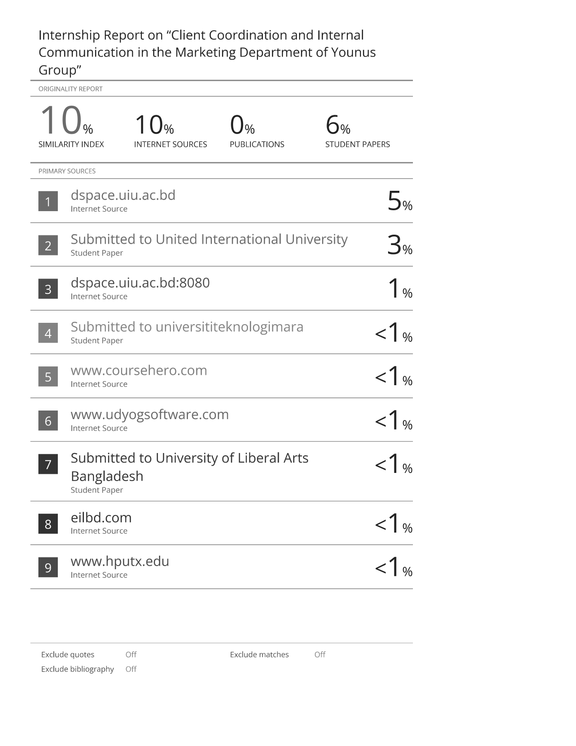

Declaration of the Student

I, Azim Ahmed Rohan, ID: 111201056, a student of the School of Business and Economics, United International University, hereby declare that the internship report titled
“Client Coordination and Internal Communication in the Marketing Department of Younus Group”
has been prepared as part of the requirements for the completion of the Bachelor of Business Administration (BBA) degree, majoring in Management Information Systems (MIS).
I also state that this report is based on my own experience during the internship period of Younus Group and has not been submitted to any other institution, college or university for the award of any degree, diploma or certificate.
The materials contained in this report is original, except where due credit have been stated and source referenced.

Azim Ahmed Rohan
ID: 111 201 056
BBA (MIS)
United International University

Corporate Evidence
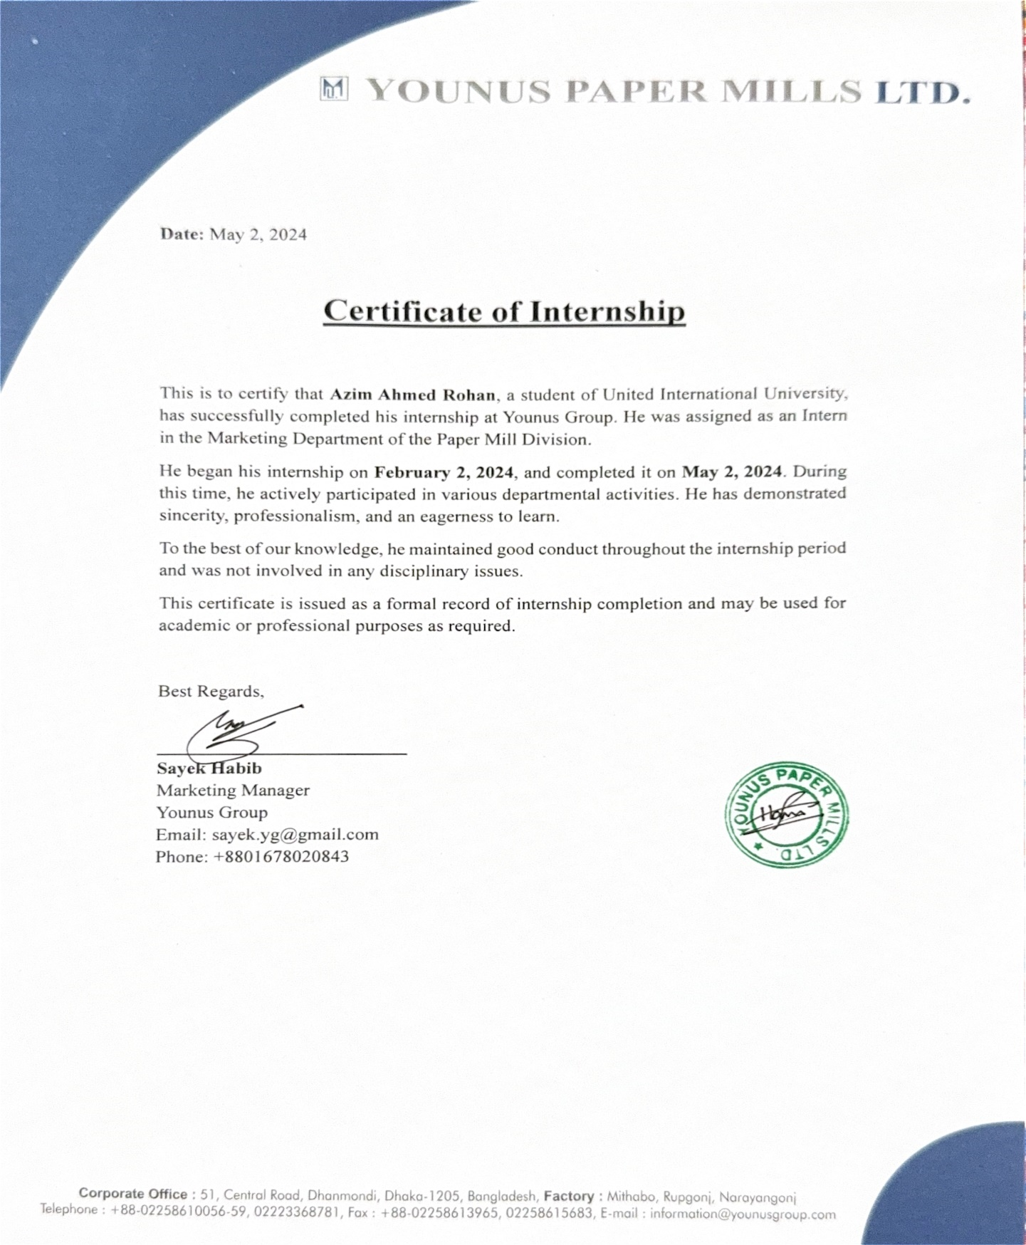

Acknowledgement

First and foremost, I would like to express my heartfelt gratitude to the Almighty for granting me the strength, patience, and determination to complete this internship and prepare this report successfully.
My heartfelt thanks go to my academic supervisor, Mr. Ahmed Imran Kabir, Lecturer, School of Business and Economics, United International University, for his continuous guidance, encouragement, and constructive criticism during the preparation of this report. Thank you for your support and guidance, you have greatly influenced the direction and quality of my work.
I sincerely thank Sayek Habib, Marketing Manager, Younus Group, who has blessed me with the opportunity to undergo my internship & practical experience in the marketing department of the Paper Mill Division. Having his support, knowing practical knowledge, and receiving constructive suggestions enriched my learning and provided me with great exposure to corporate.
I am grateful to all the employees and colleagues at Younus Group who welcomed me warmly and supported me throughout my internship. Their cooperation and willingness to share knowledge made my experience more meaningful and insightful.
Lastly, I would like to thank my family and friends for their continuous motivation and encouragement, without which this journey would not have been possible.

Executive Summary

This report is based on a three-month internship completed at Younus Group, specifically in the Marketing Department of the Paper Mill Division, from February 2, 2024, to May 2, 2024. The internship was part of the Bachelor of Business Administration (BBA) program, majoring in Management Information Systems (MIS) at United International University.

During the internship, I worked under the supervision of the Marketing Manager, where my key responsibilities included handling client communication, preparing quotations, confirming orders, and coordinating with the Accounts and Factory departments. While I did not run the ERP myself, I worked with departments that ran a Tally-based ERP for management of order status, documentation, and production schedules.
The report showcases the real-world application of MIS principles in daily operations, particularly with client coordination and internal communication. A summary of the company structure, trends in the paper industry and the main challenges such as limited production capacity, which often made it restricted to accepting new clients.

Overall, the internship provided practical exposure to interdepartmental coordination and reinforced the importance of communication, accuracy, and system-based operations in a large manufacturing environment.

Table of Contents
Letter of Transmittal III
Certification of Similarity Index IV
Declaration of the Student V
Corporate Evidence VI
Acknowledgement VII
Executive Summary VIII
CHAPTER 1: 1
INTRODUCTION 1
1.1 Background of the Report 2
1.2 Objectives of the Report 2
1.2 Rationale of the Report 3
1.3 Scope and Limitations of the Report 4
1.4 Definition of Key Terms 4
CHAPTER 2: 6
COMPANY AND INDUSTRY PROFILE 6
2.1 Company Analysis 7
2.1.1 Overview and History 7
2.1.2 Paper Mill Division 8
2.1.3 Divisions Beyond Paper 9
2.1.4 Order Fulfillment Process 10
2.1.5 SWOT Analysis 10
2.2 Industry Analysis 11
2.2.1 Specification of the Industry 11
2.2.2 Size, Trend, and Maturity of the Industry 12
2.2.3 Industry SWOT Analysis 12
CHAPTER 3: 15
INTERNSHIP EXPERIENCE 15
3.1 Position, Duties, and Responsibilities 16
3.1 Training & Development 16
3.2 Contribution to Organization / Operations 17
3.3 Evaluation 18
3.4 Skills Applied 19
CHAPTER 4: 20
CONCLUSIONS AND KEY FACTS 20
4.1 Recommendations 21
4.2 Key understanding 22
4.3 Conclusion 23
Reference 24

CHAPTER 1:

INTRODUCTION

Background of the Report

As part of the Bachelor of Business Administration (BBA) program at United International University, students are required to complete an internship in a relevant industry to bridge academic knowledge with real-world professional experience. This report is based on my three-month internship at Younus Group, conducted from February 2, 2024, to May 2, 2024, within the Marketing Department of the Paper Mill Division.
Younus Group is one of the largest industrial conglomerates in Bangladesh, It operates in diverse fields from paper to textiles, food, cold storage, logistics, dredging, media, and real estate. Its Paper Mill Division is perhaps the most vibrant amongst them, producing white liner, brown liner, simplex, kraft paper, writing and printing paper, tissue, media paper and aluminum il an extensive range of products.
As an intern in the Marketing Department, I was directly involved in assisting one of the department managers responsible for operations across three major paper mills. My key responsibilities included communicating with clients, preparing and sending quotation emails, confirming orders, and forwarding the finalized details to the Accounts Department for further documentation and processing. I also observed and supported the coordination between departments to ensure timely delivery and client satisfaction.
I did not use the ERP software directly, but I was in constant contact with departments that used a customized ERP system based on Tally, which was significant for data exchange, inventory control, and orders tracking. It also made me aware of how formalized communication and coordination between departments are indispensable for a business to run effectively in a mass manufacturing setup.

1.2 Objectives of the Report

The primary objective of this report is to document my internship experience at Younus Group and reflect on the business processes related to client coordination, internal communication, and operational workflow within the Marketing Department. The specific objectives are:
- To elaborate about the roles and responsibilities handled during the course of internship.
- To understand the order processing and communication flow from Marketing to Accounts and Factory departments.
- It keeps us aware of the principles associated with MIS through the venue of business coordination even when software is indirectly used.
- Research the significance of meticulous communication and enough functioning between various departments in the successful execution of bulk industrial orders.
- To connect academic MIS concepts with practical tasks in a marketing and manufacturing context.

Rationale of the Report

In large industrial organizations, effective coordination between clients and internal departments is usually paramount. In a paper mill where orders fall in the range of 50 to 60 metric tons, miscommunication, even by a small margin can result in delays or mistakes or even dissatisfied clients. I was involved in a large part of this coordination process answering client queries, checking on order confirmations, and keeping the Accounts and Factory department updated on a real-time basis through my internship.
While I did not directly use MIS or ERP software, I witnessed its application in real-time through dashboards and process workflows that guided decision-making. The ERP system was used by the Accounts and Factory departments to manage order fulfillment, invoicing, VAT processing, and delivery scheduling.
My internship also helped me realize, from an MIS perspective how critical structured data, digital tools and timely communication is for efficient workflow management, especially in B2B settings. Thus, not only does this report meet an academic requirement for me, but it also serves as an example of what I have learned from my management information systems class and how the concepts are applied on a day-to-day basis on this job, even for a non-technical position/task.

Scope and Limitations of the Report

This report is limited to the internship period at Younus Group, specifically within the Marketing Department of the Paper Mill Division. The scope includes activities related to client coordination, order confirmation, and internal communication with the Accounts and Factory teams.
However, several limitations exist:
- Limited Duration: The three-month internship provided only a short-term view of operations, preventing long-term performance analysis or participation in strategic planning.
- Restricted System Access: I did not directly operate the ERP software, although my role was dependent on outputs from the system.
- Confidentiality Constraints: Sensitive pricing models, financial data, and client contracts were not accessible for confidentiality reasons.
- Departmental Focus: My experience was limited to the Marketing Department and does not cover broader organizational units such as Finance, HR, or Production in depth.

Definition of Key Terms

Management Information Systems (MIS): A discipline that focuses on using information, data, and systems to support managerial decision-making and improve business efficiency.
Client Coordination: The process of managing professional communication with clients regarding quotations, order confirmations, delivery schedules, and after-sales support.
Order Processing: The workflow that starts with client confirmation and ends with product dispatch, involving multiple departments such as Marketing, Accounts, and Factory.
ERP (Enterprise Resource Planning): A software system that integrates core business processes such as sales, accounting, production, and inventory. Younus Group uses a custom ERP platform built on Tally.
Quality Control (QC): A standard procedure to ensure that the products meet client specifications before delivery.
Paper Mill Products: Industrial paper products such as liner board, kraft paper, writing and printing paper, simplex, tissue, and aluminum foil used in packaging and manufacturing industries.

CHAPTER 2:

COMPANY AND INDUSTRY PROFILE

2.1 Company Analysis

Overview and History

Younus Group is one of the most prominent and diversified industrial conglomerates in Bangladesh, with a strong reputation for reliability, innovation, and growth. The organization was founded in 1981 by Mohammed Younus as a modest cold storage business. Over the following decades, it successfully expanded into various industrial sectors, transforming into a multi-business group that contributes significantly to the national economy.
As of 2024, Younus Group operates more than 36 companies and employs approximately 2,356 direct employees across its various enterprises. Its headquarters is located in Dhaka, while its production and logistics operations are spread throughout key industrial zones such as Narayanganj, Munshiganj, Gazipur, and Chattogram. The Group’s success is rooted in its ability to maintain a balance between modern industrial practices, sustainability, and long-term client relationships.
Younus Group's business operations span a wide range of industries, including:
- Paper Manufacturing: A flagship sector for the group, with seven major paper mills producing a variety of industrial-grade and specialty paper products.
- Cold Storage and Agro-Processing: The group owns several high-capacity cold storages in Munshiganj and beyond, supporting both domestic and export-oriented agricultural products.
- Textile and Spinning: The group owns modern textile and spinning facilities that serve the garment and export sectors.
- Food Processing: Through subsidiaries like Bikrampur Potato Flakes, Younus Group adds value to agro-based raw materials.
- Real Estate and Infrastructure: Engaged in residential and industrial real estate development across Bangladesh.
- River Dredging and Inland Logistics: Operates a fleet of dredgers and cargo vessels to support its logistics and port-based operations.
- Education and Media: Manages institutions and operates a media outlet, demonstrating its social and cultural involvement.
- E-commerce and IT: In recent years, the group has invested in digital commerce platforms and software development initiatives.
The group’s Paper Manufacturing Division is one of its largest and most established arms, contributing significantly to its revenue and industry presence. The division includes companies such as Younus Paper Mills Ltd., Sonali Paper & Board Mills Ltd., Younus Newsprint Mills Ltd., and several others, producing a wide array of products including kraft paper, white and brown liner, simplex, writing and printing paper, media paper, tissue, and aluminum foil.
The Younus Group has a well-deserved reputation for corporate governance, transparency, and environmental awareness. It has proudly attained many national awards such as a Highest VAT Paying Company in 2015. The founder, Mohammed Younus has been awarded as CIPs (Commercially Important Person) by the Government of Bangladesh for several times as recognition of his contribution towards national economic development.
Today, Younus Group continues to grow by embracing modern technology, implementing ERP systems across its operations, and maintaining a people-first approach. Its strategic vision aims to expand its regional and global presence, strengthen sustainability practices, and build long-term partnerships in both industrial and social sectors.

Paper Mill Division
The paper manufacturing arm comprises seven mills:
- Ananta Paper Mills Ltd. (est. 1988): Produces Kraft and newsprint (7,300 MT/yr)
- Younus Fine Paper Mills Ltd. (est. 2006): Produces fine, writing, and printing papers (35 MT/day)
- Younus Newsprint Mills Ltd. (est. 2006): Produces newsprint (34 MT/day) .
- Younus Offset Paper Mills Ltd. (est. 2007): Produces media paper using modern Chinese/Japanese machines (20 MT/day)
- Younus Paper Mills Ltd. (est. 2001): Produces white newsprint, kraft, tissue, cigarette and decorative paper, with 36,200 MT capacity
- Sonali Paper & Board Mills Ltd. (SPBML, est. 1977/2007): Produces liner, board, simplex, duplex and writing papers (33,50 MT/yr); now includes aluminum foil production (100k containers/day)
- Universal Paper & Board Mills Ltd. (acquired 2007): Focuses on media board paper (1,800 MT/yr) .
Products: White liner, Brown liner, Simplex, writing/printing paper, kraft paper, media board, tissue, aluminum foil, newsprint, cigarette & decorative paper .
Production Locations: Mainly in Rupganj & Narayanganj, with facilities at Jatramura, Gazipur, and Mithabo .
Clients: B2B clients, packaging firms, consumer goods manufacturers, wholesalers orders usually in volumes of 50–60 MT minimum.

Divisions Beyond Paper
The group has made significant strides in various sectors, contributing to the economy and creating numerous job opportunities. In the Cold Storage & Agro sector, their multiple storage facilities in Tongibari and Munshiganj play a crucial role in preserving potatoes and other agro products, with capacities ranging from 6,400 MT to 10,000 MT. This ensures that the produce remains fresh and is available throughout the year.
In the Food Processing sector, Bikrampur Potato Flakes, with an annual capacity of 7,200 MT, supports agro exports and adds value to the agricultural produce. This not only boosts the local economy but also enhances the quality and marketability of the products.
The Textile & Spinning sector is represented by Younus Spinning Mills, which has been in operation since 2005. The mill produces yarn with an annual capacity of approximately 7.35 million lbs, catering to the needs of the textile industry and contributing to the country's export earnings.
In the Logistics & Dredging sector, the group owns dredging units and transport services that support its industrial operations. This ensures the smooth and efficient movement of goods and materials, which is vital for the overall productivity of the group.
Additionally, the group has ventured into Media, Real Estate, Education, IT, and E-commerce. They operate Sonali News and Sonali Bazar, along with several educational and technology ventures. These initiatives not only diversify the group's portfolio but also contribute to the development of these sectors, providing valuable services and opportunities to the community.

Order Fulfillment Process

- Payment confirmation from client → Marketing forwards order to Accounts for invoicing (VAT, chalan, official paperwork).
- Accounts/process team → Factory team, scheduling production.
- On delivery day, factory manager verifies client vehicle arrival and confirms against the order.
- Quality Control (QC) is conducted at the loading bay.
- Once QC passes, the product is loaded and dispatched
This workflow ensures accountability at each stage and seamless inter-departmental coordination.

SWOT Analysis

Strengths
- Diversified business across paper, textiles, agro-processing, cold storage, logistics, media, and real estate
- Operational experience of over 40 years in the industry
- Factory, transport, and ERP system integrated infrastructurepetitive
- Well-established brand with high brand equity in industrial B2B sectors
- Diverse client portfolio and large-scale manufacturing capabilities serving multiple industries
Weaknesses
- A few sectors are still operating with semi-automation or manual interventions
- High dependency on imported inputs in the major sectors of paper, textile
- Some of the frontline departments like marketing do not have direct access to the ERP
- Less exposure for brands in customer facing or global e-commerce sites
- Reliance on local infrastructure (roads, utilities) at risk of disruption
Opportunities
- Rising demand for eco-friendly packaging, tissue, processed food, and agro-exports
- Technological upgrades and full ERP integration across divisions
- Expansion into international markets (tissue, food, aluminum foil, yarn)
- Government incentives for local industrial development and exports

Threats
- Severe competitive pressure from domestic players in each sector (Bashundhara in paper, Square in agro food, etc.)
- Global fluctuations in price of raw materials and foreign exchange
- Competition from low-cost countries in imports, goods such as paper, textiles.
- Large-factory political, regulatory and environmental risks

Industry Analysis

Specification of the Industry

In Bangladesh, the paper manufacturing sector has been considered the industrial backbone that makes almost every product ranging from kraft paper, white and brown liner, simplex and duplex boards, newsprint, tissue, aluminum foil paper, writing and printing paper, and media paper. It serves as the backbone for many key services, packaging, publishing, garments, consumer products, food processing, and export led manufacturing.
This sector is mainly operated on a B2B (business to business) basis wherein large manufacturers providing to corporate clients in bulk. Orders are generally made in batches of at least 50–60 metric tons trench at a time to make production and transport feasible. These manufacturing operations rely heavily on machinery, technical skills.
Production facilities are mostly concentrated in industrial hubs such as Narayanganj, Munshiganj, and Gazipur. Most mills integrate quality control systems, logistics coordination, and internal ERP platforms to ensure smooth operations from procurement to product dispatch.

Size, Trend, and Maturity of the Industry

The paper and pulp industry in Bangladesh has experienced consistent growth over the past decade, with approximately 100 paper mills in operation as of 2024. The industry currently produces over 1.5 million metric tons of paper annually, serving both domestic and export markets.
The increase in domestic manufacturing, expansion of FMCG sector and e-commerce activity has resulted in strengthening the demand for packaging paper, especially kraft paper, liner boards and simplex, the report says. Demand for writing and printing paper has held steady, while hygiene consciousness and diversification in packaging have formed growth segments in tissue and foil-based paper.
Although the industry has made progress in terms of technological advancement, including the adoption of ERP systems, automation, and recycling methods, it still faces challenges in achieving uniform quality standards, optimizing energy consumption, and expanding innovation capabilities. Large players such as Bashundhara Group, Younus Group, Meghna Group, and Partex Group lead the sector with modern production lines, integrated management systems, and diversified product portfolios.
The industry is in a transitional stage—progressing from growth towards maturity—where technological adaptation, sustainable practices, and cost competitiveness are becoming defining factors for long-term sustainability.

Industry SWOT Analysis

Strengths
- Consistent demand for paper products across packaging, printing, and hygiene sectors.
- Increasing automation and ERP adoption by major manufacturers.
- Availability of low-cost skilled labor and favorable geographic positioning for logistics.
- Potential for export expansion in South Asia and Middle East regions.
Weaknesses
- Heavy dependence on imported raw materials such as pulp, whitening agents, and chemical coatings.
- Limited innovation in product development and value-added paper grades.
- Quality inconsistency among small and mid-sized mills.
- Vulnerability to power outages and utility inefficiencies in certain industrial zones.

External Economic Factors
- Volatility in global raw material prices directly impacts production costs.
- Fluctuations in foreign exchange rates affect both import costs and export margins.
- Inflationary pressures on logistics and packaging materials increase operational expenses.

Technological Factors
- Gradual adoption of ERP systems, automation tools, and quality control machinery in leading mills.
- Limited integration of advanced technologies such as AI-driven quality control or digital B2B ordering platforms.
- The use of locally modified machinery in small mills limits technological efficiency.

Barriers to Entry
- High capital investment required for machinery, utilities, and regulatory compliance.
- Stringent environmental regulations related to wastewater management and emissions.
- The requirement for a minimum viable production scale (e.g., 50+ MT per order) restricts small entrants.
- Strong competition from large established firms with existing client bases and economies of scale.

Threat of Substitutes
- In publishing: shift toward digital platforms reducing demand for printing paper.
- In packaging: competition from plastic packaging, although government restrictions on plastic use offer protection.
- Imported low-cost recycled papers pose pricing threats, especially from regional exporters.

Industry Rivalry
The paper manufacturing industry in Bangladesh is highly competitive, particularly in the packaging paper segment. The primary competitors include:
- Bashundhara Paper Mills
- Meghna Paper Mills
- Partex Pulp & Paper Mills
- Papertech Industries
- Amber Super Paper Ltd
- Platinum Print & Pack Ltd
- Master Simex Paper Ltd
Competition is based on product quality, pricing, lead time, client servicing, and the ability to meet bulk order requirements. Companies that operate integrated ERP systems and maintain strong interdepartmental coordination often gain a competitive edge in this sector.

CHAPTER 3:

INTERNSHIP EXPERIENCE

Position, Duties, and Responsibilities

During my three-month internship at Younus Group (February 2 to May 2, 2024), I was placed in the Marketing Department of the Paper Mill Division, reporting directly to a senior Marketing Manager responsible for three paper manufacturing units. As a student majoring in Management Information Systems (MIS), I had the opportunity to engage in a business environment where communication, coordination, and information flow were key to large-scale industrial success.
My role was positioned at the intersection of client interaction and internal departmental workflow. I worked closely with existing clients to handle communication regarding quotation requests, order confirmation, and payment coordination. Once an order was confirmed and payment was received, I was responsible for forwarding the transaction details to the Accounts Department, where the next set of formal procedures including VAT documentation, chalan creation, and billing paperwork were executed.
In addition to managing communication and documentation, I also participated in internal meetings, maintained records of ongoing client orders, tracked pending responses, and followed up with departments to ensure deadlines were met. I did not operate the ERP software directly, but my tasks were deeply interlinked with the custom ERP system based on Tally, as all official documentation and order status updates were managed through it. My communications were often guided by the information retrieved from ERP dashboards maintained by the Accounts and Factory department.
This experience helped me understand not only the functional structure of a B2B marketing operation, but also how data dependency and inter-departmental synergy drive fulfillment in a large manufacturing organization.

Training & Development

While there was no formal training session or technical onboarding, I was inducted into the department through supervised, task-based learning. The Marketing Manager I reported to provided real-time feedback on my emails, documentation approach, and internal communication style. I quickly adapted to the company’s communication culture and became proficient in professional correspondence, client follow-up etiquette, and workflow documentation.
My operational tools did not include the ERP, but I got to learn substantially by seeing how various departments more so Accounts and Factory Management leveraged it for order tracking, payment verification, inventory management and production scheduling. I learnt about applications of MIS principles from practical example such as how timely communication supported by verified data from the system avoids production and logistics to be in chaos.
Moreover, I was introduced to B2B communication dynamics, which differ significantly from consumer-facing roles. The tone, timing, and precision required in dealing with bulk industrial clients taught me the value of clarity, follow-through, and accountability critical soft skills that are often undervalued in theoretical learning.

Contribution to Organization / Operations

My contribution to Younus Group was centered around process reliability and communication consistency. In an environment where a single order involves 50–60 metric tons of product and coordination across multiple departments, maintaining clear, prompt, and well-documented communication is vital.
Some of my specific contributions included:
- Preparing and sending quotations based on client requests and product availability.
- Following up on payments, and once confirmed, ensuring the order was passed to the Accounts Department without delay.
- Maintaining updated records of order status, client responses, and internal handovers to prevent miscommunication.
- Participating in internal coordination between Marketing, Accounts, and Factory department to align on vehicle scheduling, delivery confirmation, and QC clearance.
- Assisting the Marketing Manager with order summaries and communication templates, enabling faster turnaround during high-demand periods.
While my tasks may appear operational in nature, they had a direct impact on the overall delivery timeline, client satisfaction, and internal accountability. By handling the groundwork communication and documentation, I enabled higher-level staff to focus on strategic decision-making and cross-factory coordination.

Evaluation

My internship at Younus Group was a highly enriching and professionally transformative experience. I was evaluated based on my ability to work independently, adapt quickly to changing priorities, and maintain professional standards in communication and documentation.
From the first month, I was entrusted with direct client emails and internal handovers, which reflected the confidence my supervisor had in my ability to handle sensitive and detail-oriented responsibilities. My manager appreciated my consistency, my proactive nature in following up with clients, and my structured approach to tracking order progress.
It also reinforced my realization that MIS is so much more than just working a software or maintaining a database. Instead, it serves a larger function of accuracy of information, alignment of workflow, and strategic coordination - all of which I was indirectly facilitating direct to the people without a use of the ERP platform.

Skills Applied

Throughout the internship, I was able to apply and enhance a wide range of academic and professional skills:
Skill Area | Application in Internship
Communication Skills | Drafted business emails, handled client follow-ups, and communicated across departments.
Coordination | Ensured smooth workflow between Marketing, Accounts, and Factory department.
MIS Awareness | Understood how ERP systems like Tally drive data consistency and workflow visibility.
Analytical Thinking | Tracked order histories and client response patterns to reduce delays and improve scheduling.
Documentation | Maintained logs of quotations, confirmations, and interdepartmental handovers.
Time Management | Managed simultaneous order communications under strict delivery timelines.
Professionalism | Learned corporate behavior, reporting etiquette, and accountability under a senior manager.
This combination of soft skills and domain knowledge has strengthened my foundation as a future MIS professional, especially one looking to work at the intersection of technology, communication, and operations.

CHAPTER 4:

CONCLUSIONS AND KEY FACTS

Recommendations

Based on my internship experience at Younus Group, particularly within the Marketing Department of the Paper Mill Division, I have identified two strategic areas where the company could improve its operational efficiency and long-term service capabilities:

1. Increase Production Capacity to Meet Rising Demand

One of the most pressing challenges I observed was the company's struggle to accommodate new client orders due to limited production capacity. The demand for core products such as white liner, brown liner, simplex, and kraft paper consistently exceeded supply, often forcing the marketing team to decline orders unless clients were willing to pay above market rates. During this time, the factories were required to operate even on off-days to fulfill existing commitments, which, while effective in the short term, is not sustainable over the long run.
To address this, Younus Group should invest in something better which is expanding the production infrastructure it can be either by enhancing the production line up or the machinery there in addition to that they can also construct a new manufacturing unit to meet the increasing demand. This would allow the company to work with wider client base, ease the operational pressure and allow for overall ease of delivery.

2. Promote Active Utilization of the ERP System Across Decision-Makers
Younus Group has implemented a capable ERP system, customized on the Tally platform, which is used by several departments including Accounts and Factory Operations. However, during my internship, I noticed that some decision-makers including those in the Marketing Department did not consistently engage with the ERP system, even when they had access. Instead, they often relied on verbal updates or informal tracking, which occasionally led to communication delays or missed details.
Encouraging all relevant personnel, particularly within sales and marketing functions, to actively utilize the ERP dashboard would lead to faster decision-making, improved accuracy in client communication, and greater transparency across departments. This would further ensure that the company's investment in digital infrastructure delivers its full strategic value.

Key understanding

The internship offered me invaluable insight into how client communication, interdepartmental coordination, and structured information flow function within a large-scale manufacturing environment. Some of the most important takeaways from this experience include:
- MIS principles extend beyond software operation: Even without directly operating ERP systems, I contributed to information flow and data accuracy through documentation, communication, and departmental coordination proving that MIS plays a wider role in business ecosystems.
- Communication is as critical as systems: A well-functioning ERP system is only as effective as the people who use it and communicate based on its outputs. My role bridged this gap, ensuring that what was visible in the system was accurately conveyed and executed.
- Industrial operations require precision and accountability: Handling orders ranging from 50 to 60 metric tons demands an extraordinary level of attention to detail, planning, and responsibility at each touchpoint in the process from quotation to delivery.
- Departmental roles are interdependent: No department functions in isolation. My work in marketing was directly connected to accounts and factory teams, and success depended on clear, timely communication and mutual understanding.
- Professionalism is built on reliability: In a corporate setting, especially in B2B industries, consistent follow-up, proper documentation, and courteous communication are as essential as technical skills.

Conclusion

The internship at Younus Group provided me with valuable real-world exposure to the operational dynamics of a large manufacturing organization. Being placed in the Marketing Department of the Paper Mill Division, I had the opportunity to observe and contribute to core business processes such as client handling, order confirmation, and interdepartmental coordination all of which are critical components of any industrial supply chain.
Though I did not work directly with ERP systems, my tasks were closely linked to data maintained and processed through the company's Tally-based ERP, enhancing my understanding of how structured information systems support business operations. I also learned how internal communication between departments such as Marketing, Accounts, and Factory must be timely, accurate, and well-documented to ensure efficient product delivery.
This internship strengthened my professional discipline, improved my communication and coordination skills, and provided a practical understanding of how Management Information Systems (MIS) principles are applied beyond software through people, processes, and decision-making.
In conclusion, the experience has been both educational and transformative. It has not only helped me fulfill academic requirements but has also shaped my mindset and confidence as I prepare to transition from a student to a business professional.

Reference
- Yesmeen, A. (2020). Managing Market Insights for Better Market Management: A Study on Sonali Paper & Board Mills Limited.

- Younus Group of Industries. (n.d.). About us. Retrieved July 8, 2025, from https://www.younusgroup.com

- Bangladesh Paper Mills Association. (n.d.). Home. Retrieved July 8, 2025, from https://www.bangladeshpapermillsassociation.com

- Wikipedia contributors. (n.d.). Younus Group of Industries. In Wikipedia. Retrieved July 8, 2025, from https://en.wikipedia.org/wiki/Younus_Group_of_Industries

- Quader, M. M. A. (2011). Paper sector in Bangladesh: challenges and scope of development. Journal of Chemical Engineering, 26, 41-46.

- Chowdhury, M. S. A., Rahman, M. T., Shahabuddin, A. M., Hassan, M. R., & Chowdhury, M. S. R. (2021). Implementation of enterprise resource planning (ERP) in Bangladesh-opportunities and challenges. International Journal of Business and Management, 16(11).

- Sarker, J. (2024). Enterprise Resource Planning (ERP): Opportunities, benefits and implementation challenges in Bangladesh. International Journal of Science and Business, 42(1), 71-83.

